Communication preferences

Template

Step 1:

1. In the first column, from the list of behaviors below, please choose the top 7 that most resonate with you, by marking a tick ü next to it.
2. On the second column, from the 7 behaviors that you have ticked, now select your top 5 and rank them from most like you (1) to least like you (5).

|  |  |  |
| --- | --- | --- |
| Behavior | My top 7 ü | Rank your top 5  *(1 = most like you; 5 = least like you)* |
| Likes challenges | Yes |  |
| Results focused | Yes | 3 |
| Competitive |  |  |
| Determined |  |  |
| Assertive |  |  |
| Decisive |  |  |
| Risk Taker | Yes |  |
| Sensitive to others |  |  |
| Sociable |  |  |
| Emotional |  |  |
| Stimulating |  |  |
| Outgoing |  |  |
| Optimistic | Yes | 4 |
| Enthusiastic | Yes | 2 |
| Tactful |  |  |
| Calm |  |  |
| Patient |  |  |
| Dependable |  |  |
| Supportive |  |  |
| Accommodating |  |  |
| Procedure orientated |  |  |
| Precise |  |  |
| Private |  |  |
| Systematic | Yes | 5 |
| Restrained |  |  |
| Likes numbers |  |  |
| Perfectionist | Yes | 1 |
| Critical of mistakes |  |  |

Step 2:

Now please complete your research. Here is a reminder of DiSC. The example behaviors are drawn from the previous table.

Introducing the DiSC model

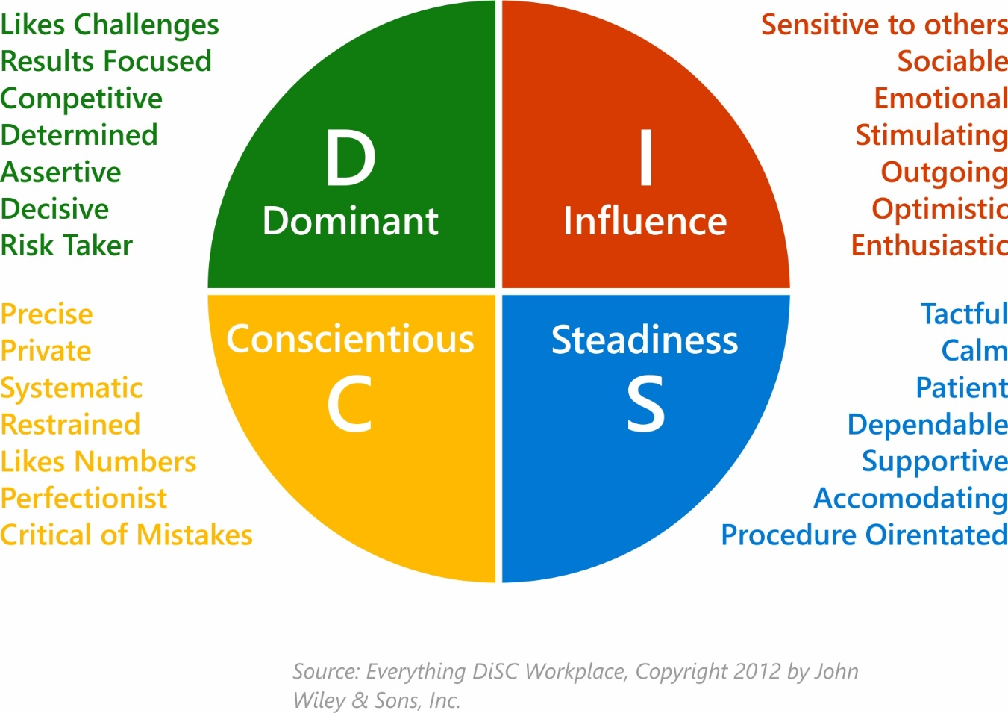

Step 3:

Following your research, answer the final 2 questions below.

1. What have you learned about yourself from the DiSC model?

I am a mixture of Dominance (D), Influence (I) and Conscientious(C). From the research I feel this is a true reflection as I can identify with many of the behaviors and can see how this comes across when I communicate and how I prefer people communicate with me. I think I flex between D, I and C, depending on the situation.

In my predominant work style, I could be seen as an abrupt communicator due to where my focus is – on results, getting the job done, being assertive and being challenged. This isn’t to say that this is my only way of communicating, as I do care what other people have to say and how they feel (this is my I preference showing), but this feels more natural when I am at home and communicating with friends and family.

1. What have you learned about DiSC and its value when communicating with others?

I think DiSC will help me adapt my conversation styles based on the other person’s preferences. I now understand how to distinguish between the different communication preferences. If someone is focusing their conversation around numbers and being systematic, then I need to be mindful of this, so they get what they need out of the conversation. Plus, this will help me influence the conversation as they will be more likely to be interested in what I’ve got to say and value my input if I respond to their preferred communication style.